CS 255 System Design Document Template

This template lays out all the different sections that you need to complete for Project Two. Each section has guidance to prompt your thinking. You will need to continually reference the interview transcript as you work to make sure that you are addressing your client’s needs. There is no required length for the final document. Instead the goal is to complete each section based on what your client’s needs are. Remove this note when you are finished, and replace all bracketed text with the relevant information.

UML Diagrams

UML Use Case Diagram
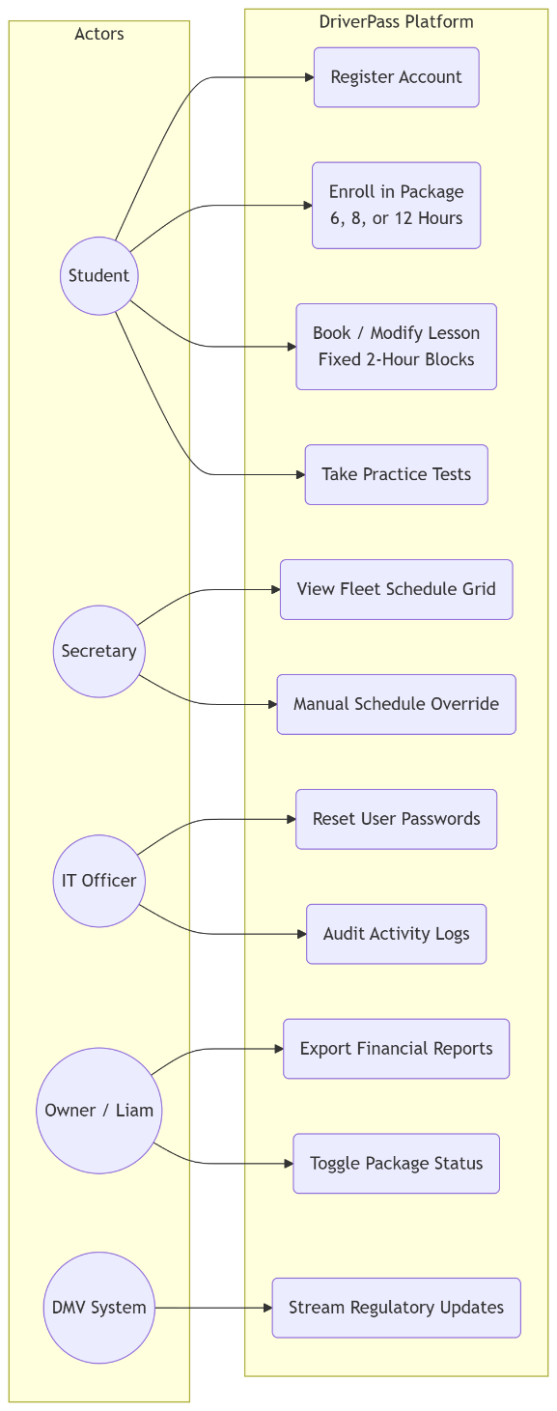

UML Activity Diagrams
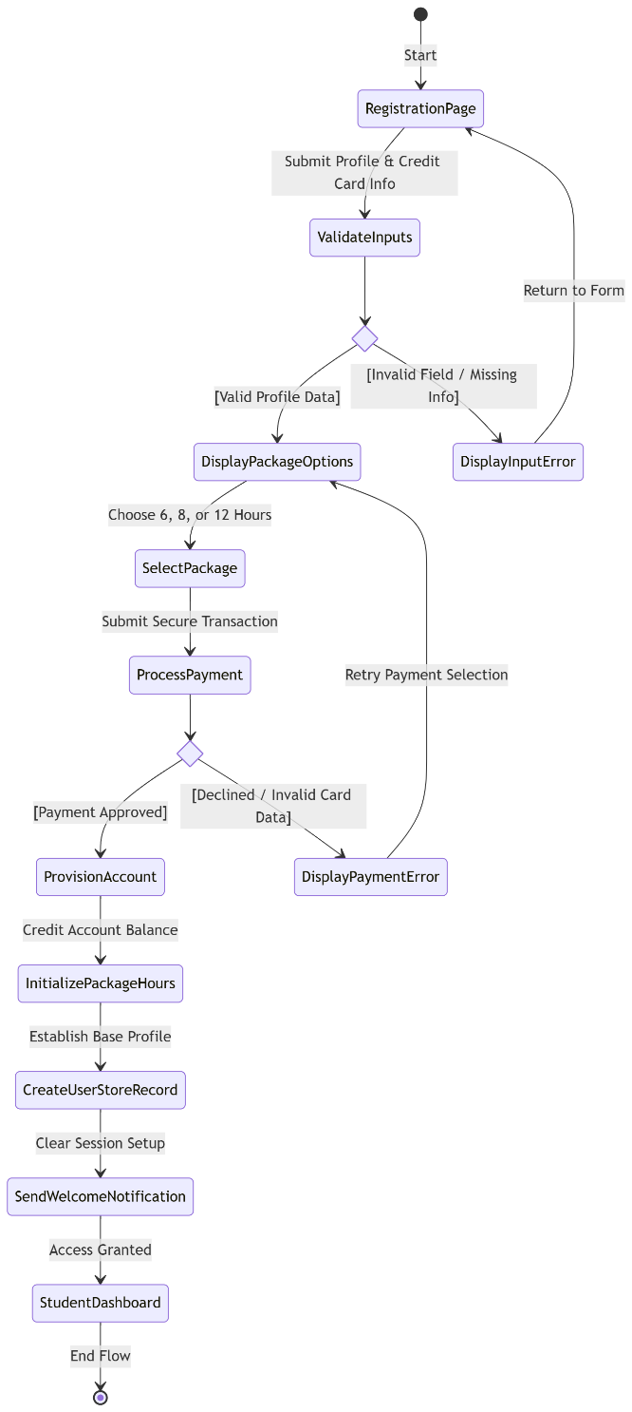
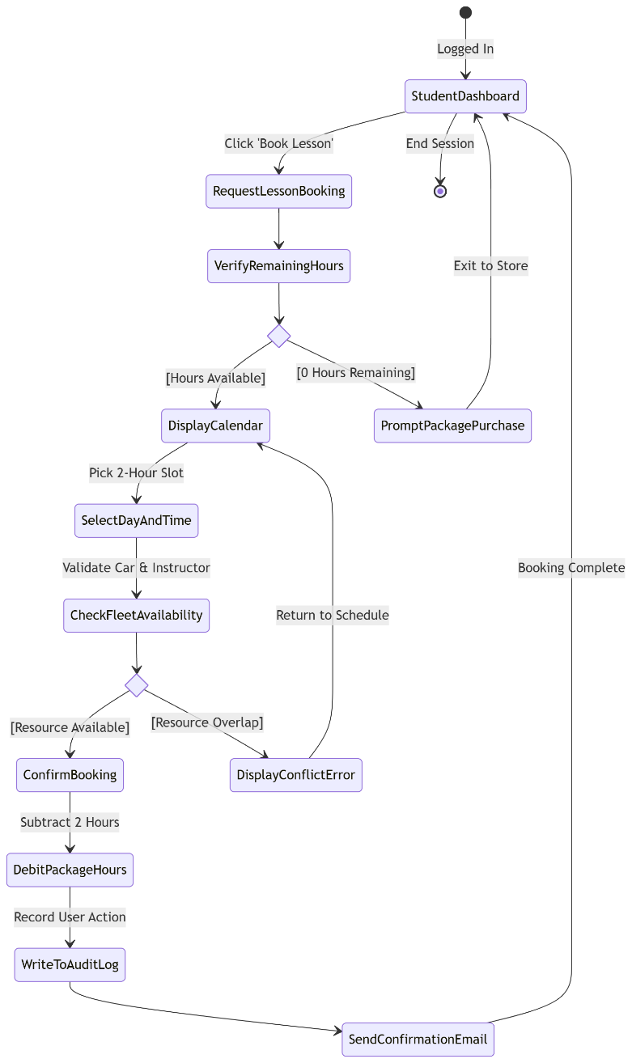

UML Sequence Diagram
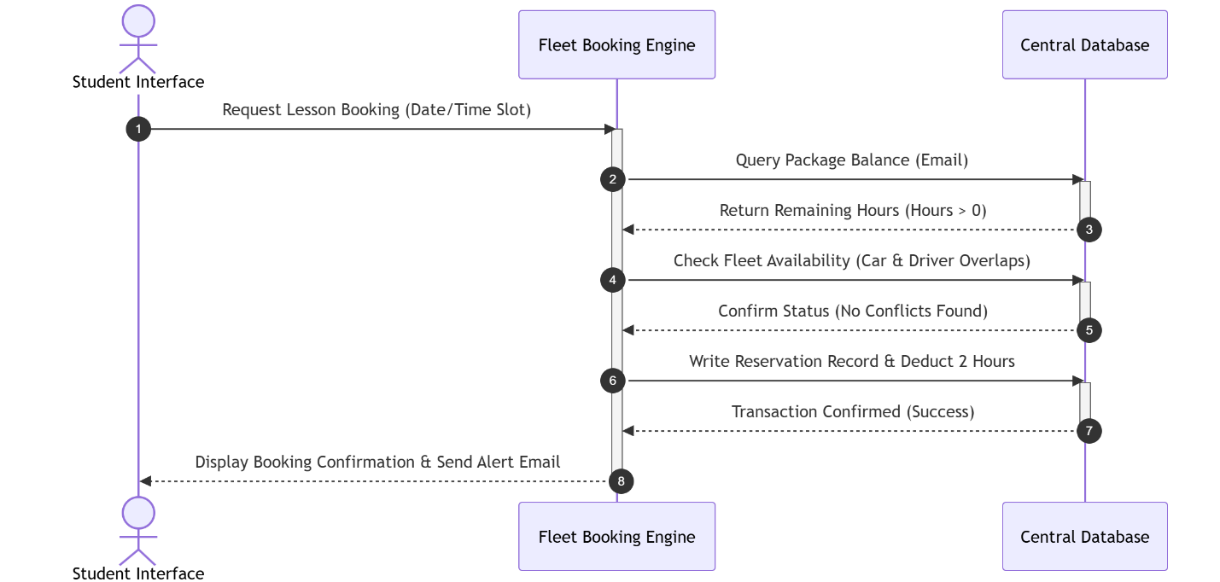

UML Class Diagram
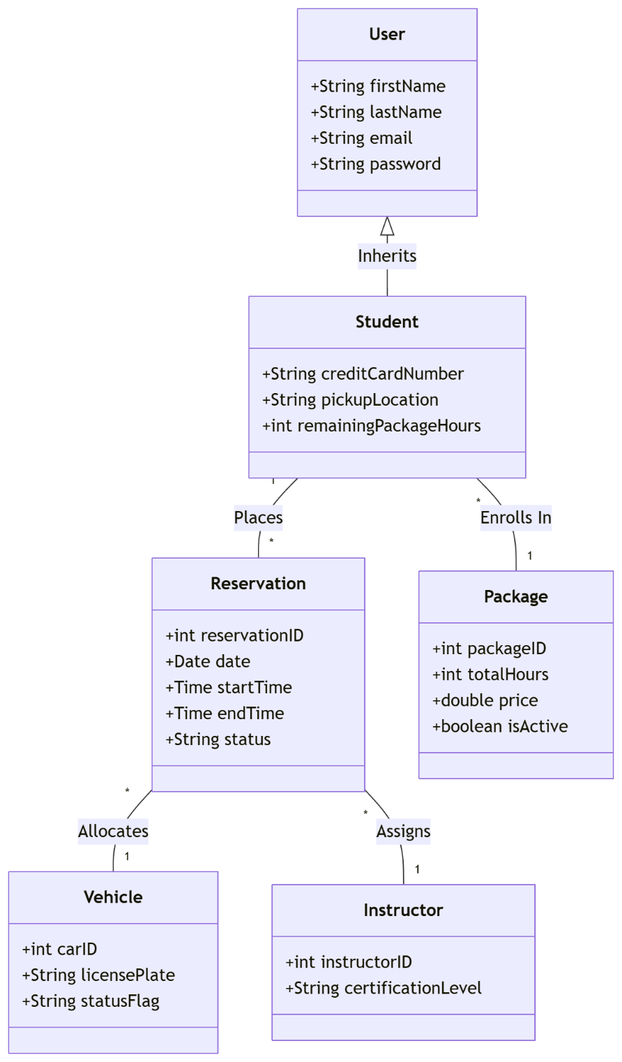

Technical Requirements

Cloud Infrastructure: The application shall be deployed utilizing an Amazon Web Services (AWS) cloud ecosystem. It must leverage a virtual server instance paired with an automated load balancer to maintain the mandatory 99.9% availability threshold.

Database Management System: To preserve data integrity across matching entities (Students, Vehicles, Drivers, and Reservations), the back end requires a robust Relational Database Management System. The system shall run on a managed relational database service configured with multi-availability zone replication to handle automated transaction backups.

Software Development Stack:

Front-End: Built with modern, responsive web layouts using HTML5, CSS3, and vanilla JavaScript to guarantee browser compatibility across mobile phone and desktop screens.

Back-End: Implemented using an object-oriented development architecture (such as Python or Java) to process role-based user logins and execute synchronized scheduling validation checks.

Security Tools & Protocols: All data exchanges between web browsers and cloud instances must be completely scrambled using HTTPS backed by TLS 1.3 encryption certificates. Administrative credentials must require Multi-Factor Authentication, and the system must interface with an automated SMTP relay service to securely dispatch verification links and security logs.

